Aim: To study different word embeddings for the representation of textual data in vectorized form
IDE: Google Collab

Theory:
Word Embedding is an approach for representing words and documents. Word Embedding or Word Vector is a numeric vector input that represents a word in a lower-dimensional space. It allows words with similar meanings to have a similar representation.

Word Embeddings are a method of extracting features from text so that we can input those features into a machine learning model to work with text data. They try to preserve syntactical and semantic information. The methods, such as Bag of Words (BOW), CountVectorizer, and TFIDF, rely on the word count in a sentence but do not save any syntactical or semantic information. In these algorithms, the size of the vector is the number of elements in the vocabulary. We can get a sparse matrix if most of the elements are zero. Large input vectors will mean a huge number of weights, which will result in high computation required for training. Word Embeddings give a solution to these problems.

Need for Word Embedding?
- To reduce dimensionality
- To use a word to predict the words around it.
- Inter-word semantics must be captured.

How are Word Embeddings used?
- They are used as input to machine learning models. Take the words —-> Give their numeric representation —-> Use in training or inference.
- To represent or visualize any underlying patterns of usage in the corpus that was used to train them.

Bag of Words
Bag of Words (BOW) is an algorithm that counts how many times a word appears in a document. Those word counts allow us to compare documents and gauge their similarities for applications like search, document classification, and topic modeling.

Tf-Idf
TF-IDF is shorthand for term frequency-inverse document frequency. So, two things: term frequency and inverse document frequency. Term frequency (TF) is basically the output of the BoW model. For a specific document, it determines how important a word is by looking at how frequently it appears in the document. Term frequency measures the importance of the word. If a word appears a lot of times, then the word must be important. For example, if our document is “I am a cat lover. I have a cat named Steve. I feed a cat outside my room regularly,” we see that the words with the highest frequency are I, a, and cat. This agrees with our intuition that high term frequency = higher importance.

TF(t) = (Number of times term t appears in a document) / (Total number of terms in the document)

IDF is used to calculate the weight of rare words across all documents. The words that occur rarely in the corpus have a high IDF score. However, it is known that certain terms, such as “I”, “a”, may appear a lot of times but have little importance. Thus, we need to weigh down the frequent terms while scaling up the rare ones

IDF(t) = log_e(Total number of documents / Number of documents with term t in it)

Pre Lab Exercise:
  - Perform BoW vectorization of the corpus
  - Perform TF vectorization of the corpus
Code:
text = ["Mozambique is a beautiful and amazing country",
"It is considered an island, since it is surrounded by countries whose official language is English.",
"Mozambique is rich in natural resources, with huge forests, capes, islands, and beaches.",

"Football is the main sport in Mozambique.",
"In the last match, the Mozambican club lost, not getting to qualify for CAN.",

"Artificial Intelligence research in Mozambique is still in a growth process.",
"Machine learning, as a branch of Artificial Intelligence, is helping the research innovation."]
#Import the libraries
import numpy as np
import pandas as pd
from sklearn.feature_extraction.text import CountVectorizer #TF-BoW
from sklearn.metrics.pairwise import cosine_similarity
#Embeddings using TF-BoW approach
tf_vectorizer = CountVectorizer()
tf_matrix = tf_vectorizer.fit_transform(text) # Transforming the text into the factorized matrix
tf_matrix
Output:
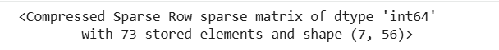
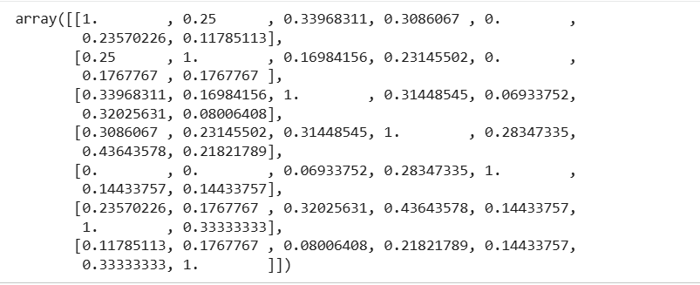

Program (Code):
- Perform the TF-IDF vectorization of the corpus
#Import the libraries
import numpy as np
import pandas as pd
from sklearn.feature_extraction.text import CountVectorizer #TF-BoW
from sklearn.feature_extraction.text import TfidfVectorizer #TF-IDF
from sklearn.metrics.pairwise import cosine_similarity
tfidf_vectorizer = TfidfVectorizer()
tfidf_matrix = tfidf_vectorizer.fit_transform(text) # Transforming the text into the factorized matrix
tfidf_matrix
#Finding out the document similarity
def doc_similarity(similarity_matrix, text):
for i in range(len(text)):
sims = similarity_matrix[i].copy()
sims[i]=-1 # Excluding the value of the sentence itself
top_index = np.argmax(sims)
print(text[i], "->", text[top_index])
doc_similarity(tfidf_similarity,text)

Results:
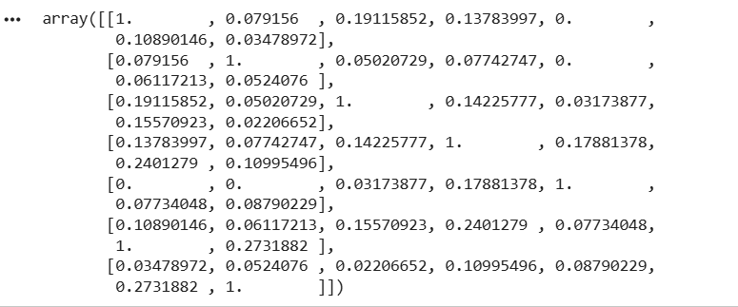

Observation:

Post Lab Exercise:
Take three documents and find similarity using
- BoW vectorization
- TF Vectorization
- TF-IDF Vectorization
Code:
import numpy as np
from sklearn.feature_extraction.text import CountVectorizer, TfidfVectorizer
from sklearn.metrics.pairwise import cosine_similarity

# Input Documents

text = [
"High-performance concrete is a construction material that is composed of coarse aggregates, fine aggregates, and bonding materials",
"The compressive strength of HPC is a key performance indicator",
"In engineering practice, determining the strength of HPC is largely based on empirical experiments"
]

# BoW Vectorization

print(" BAG OF WORDS (BoW)")
bow_vectorizer = CountVectorizer()
bow_matrix = bow_vectorizer.fit_transform(text)

print("\nBoW Matrix:\n", bow_matrix.toarray())

bow_similarity = cosine_similarity(bow_matrix)
print("\nBoW Similarity:\n", bow_similarity)

# TF Vectorization
print("\n TERM FREQUENCY (TF)")
tf_vectorizer = CountVectorizer()
tf_matrix = tf_vectorizer.fit_transform(text)

print("\nTF Matrix:\n", tf_matrix.toarray())

tf_similarity = cosine_similarity(tf_matrix)
print("\nTF Similarity:\n", tf_similarity)

# TF-IDF Vectorization
print("\n TF-IDF")
tfidf_vectorizer = TfidfVectorizer()
tfidf_matrix = tfidf_vectorizer.fit_transform(text)

print("\nTF-IDF Matrix:\n", tfidf_matrix.toarray())

tfidf_similarity = cosine_similarity(tfidf_matrix)
print("\nTF-IDF Similarity:\n", tfidf_similarity)

# Step 6: Compare Most Similar Documents
def show_similarity(similarity_matrix, text, title):
print(f"\n===== {title} Most Similar Documents =====")
for i in range(len(text)):
sims = similarity_matrix[i].copy()
sims[i] = -1
idx = np.argmax(sims)
print(f"'{text[i]}' --> '{text[idx]}'")

show_similarity(bow_similarity, text, "BoW")
show_similarity(tf_similarity, text, "TF")
show_similarity(tfidf_similarity, text, "TF-IDF")
Output:
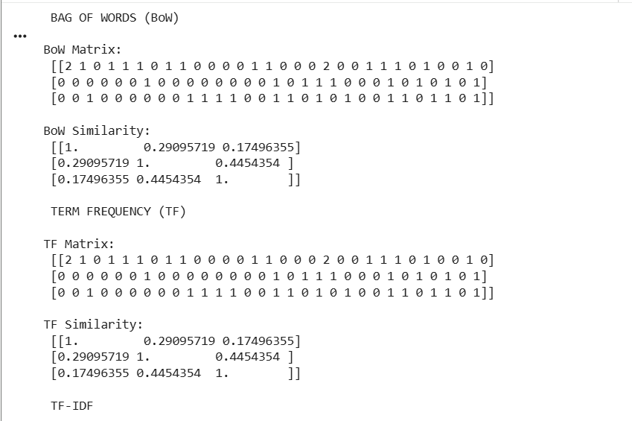
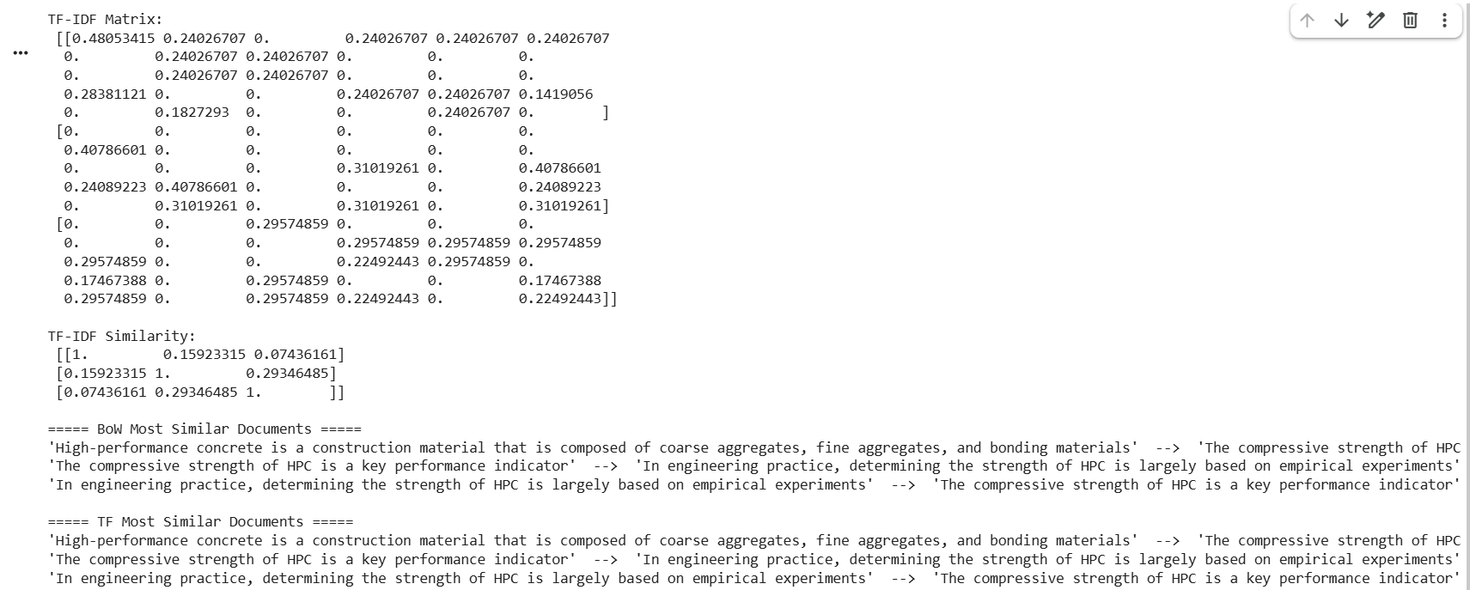
Comment on the answer obtained in each of the cases.
From the results, I could observe that the documents containing similar words show higher similarity scores, whereas unrelated documents show very low or zero similarity. Among the three methods, TD-IDF provides more meaningful similarity results by reducing the importance of common words and emphasizing unique terms, making it more effective compared to BoW and TF approaches.

